- KAGGLE DATASET

The CSV I chose was way too long, so I removed everything that wasn’t related to France so that my program doesn’t take to long to tidy it, and so it’s simpler to find a second dataset to complement it.
It contains various data about natural disaster from 2018 to 2024, all numerical except the disaster type, which makes comparing different values easier.

- WEB SCRAPE A COMPLEMENTARY DATASET

Chosen website : https://www.infoclimat.fr/climatologie/annee/2024/paris-montsouris/valeurs/07156.html (the year is changed to study from 2018 to 2024)
I chose this website because global warming is often blamed as the main reason for the increasing number of natural disasters each year.
After scrapping the data, I can see that both datasets have data from 2018 to 2024, since both are related to natural events, we can merge them to establish a link between the two.

- MERGE

I merged the first dataset days into months, and instead of getting the disaster type, we count the number of disasters per months.

- EXPLORE/VISUALISE

As you can see temperature variables don’t seem to corollate much with disaster. There is a weak correlation between temperature and months, since the months are indeed getting hotter, but it doesn’t seem to have a significant impact on the number, or even the impact of the natural disasters.
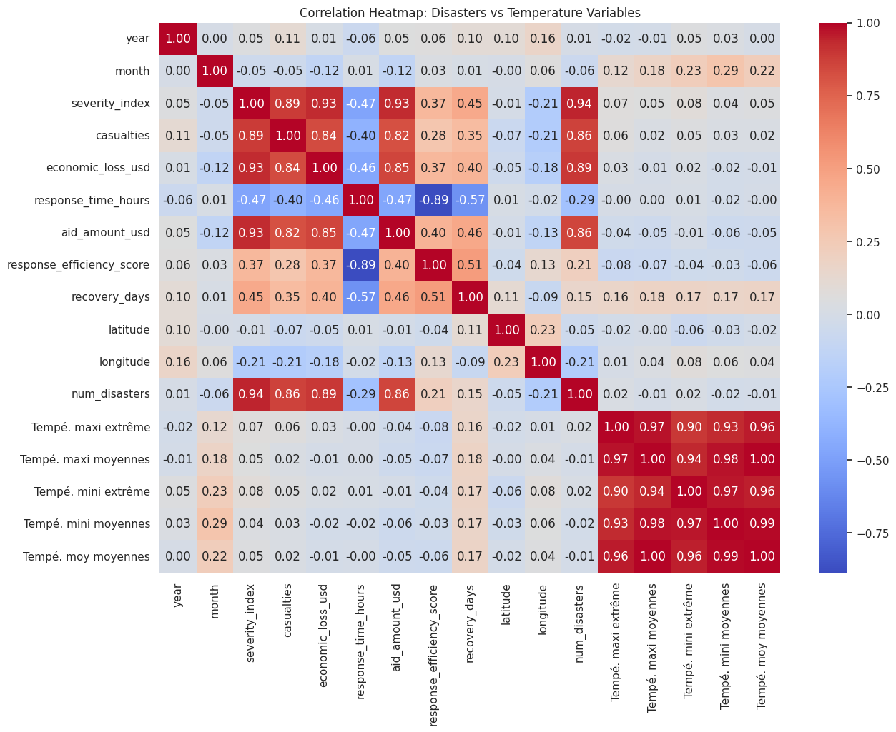
When we take a closer look, we can see that the severity index seem to be increasing as the average temperature goes up, but not by much.
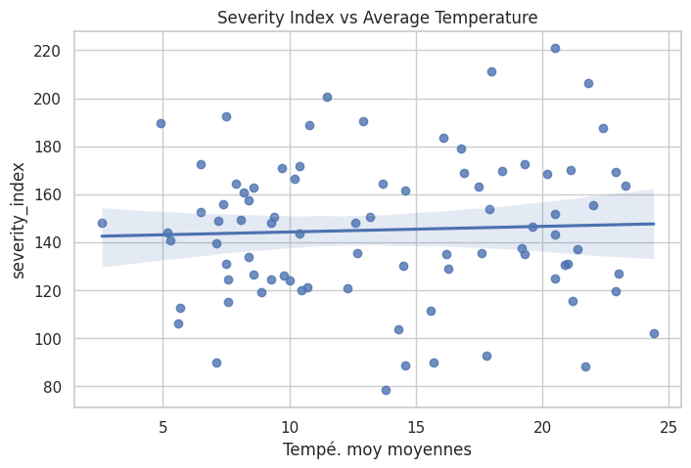

However, when we take a look at the extreme temperatures, the linear average is more inclined, so the severity of natural disaster seems to be indeed related to temperature, but since extreme temperatures are still rare, it’s not noticeable unless you focus on those.
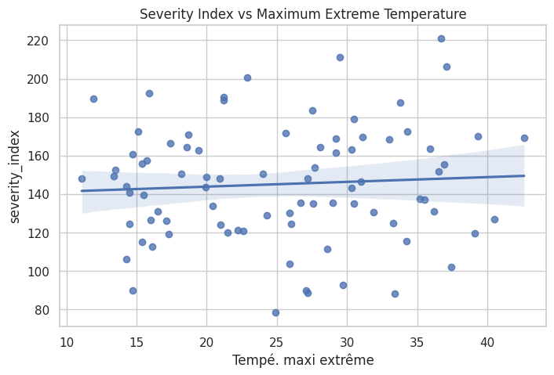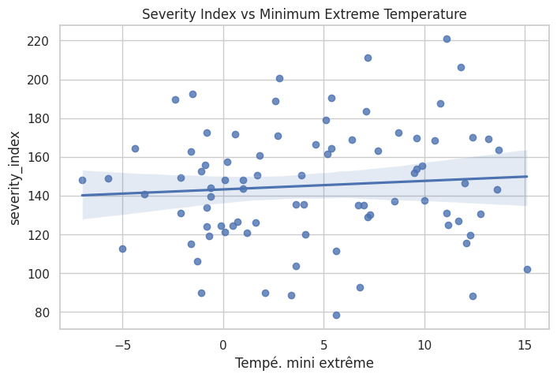

It seems to be the same for economic loss, it’s overall not affected, but when the temperatures are extreme, the loss is still more important.
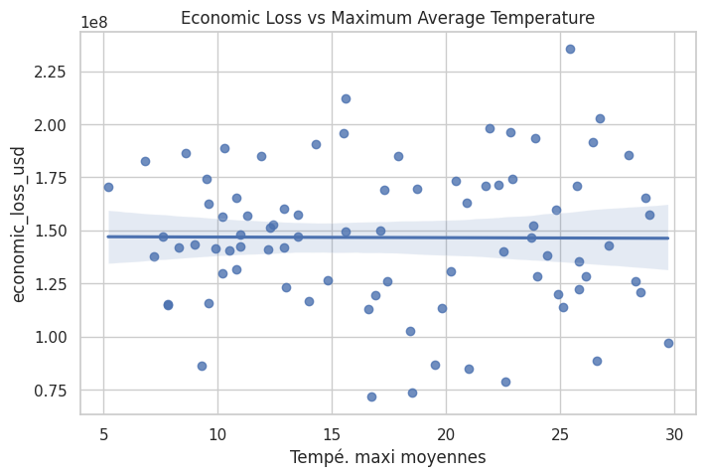
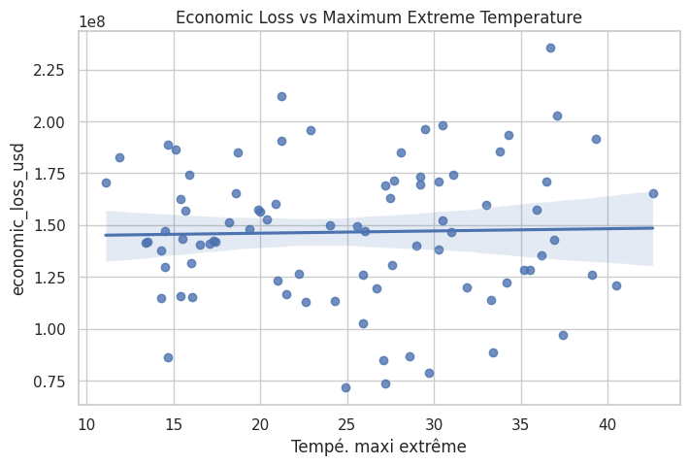

It’s something else when you look at the number of disasters and the average temperature over the year, the graphics of both of those are shockingly similar. With the exception of 2022, the values seem to be following the same trend, so it seems that the increase in heat might be an important factor when it comes to natural disasters.
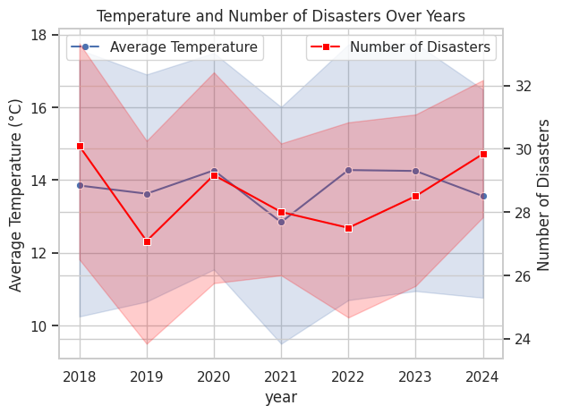

Chatgpt prompts used :
https://chatgpt.com/c/69179443-5b94-832c-9434-14eb40ae3e03
https://chatgpt.com/c/6919e4f2-c564-8326-ad2d-9212f10cd515

AI allowed me to easily produce understandable code to import and tidy my datasets, which considerably reduced the programming time before having to analyze my data.

